Tip Calculator

Assumptions Made :

* For Bill :-

Here the bill could be from $ 0 to any maximum number

* For Tip %:-

Here the tip is from 0 to 100% but it may happen if a person want to give more than 100 so that condition is also fulfilled.

* For Number of Persons:-

Here the minimum number of person is set to 1 and maximum upto 1000 .But there could be more than 1000 people too ,so that conditions is also fulfilled

Functionality of program:

1. Bill:

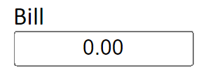

In this part you can enter the amount value you require.

1. Tip%:

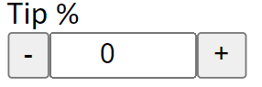

You can increment and decrement(+/-) the value here from 0 to 100. But no direct effect on result .To have the direct effect use these up and down button.

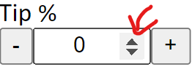

1. Number of Person:

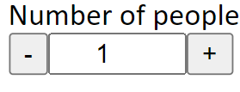

You can increment and decrement(+/-) the value here from 1 to 1000. But no direct effect on result .To have the direct effect use these up and down button.

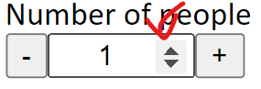

1. The tolal tip and bill per person will be displayed automatically .